**DAILY ONLINE ACTIVITIES SUMMARY**

|  |  |  |  |  |  |  |  |  |
| --- | --- | --- | --- | --- | --- | --- | --- | --- |
| **Date:** | **18 June 2020** | | | | | **Name:** | **K ISHA HEGDE** | |
| **Sem & Sec** | **4th sem, 2nd year** | | | | | **USN:** | **4al18cs031** | |
| **Online Test Summary** | | | | | | | | |
| **Subject** | | **--** | | | | | | |
| **Max. Marks** | | **---** | | **Score** | | | **--** | |
| **Certification Course Summary** | | | | | | | | |
| **Course** | **Introduction to R** | | | | | | | |
| **Certificate Provider** | | | **GreatLearning** | | **Duration** | | | **3 hours** |
| **Coding Challenges** | | | | | | | | |
| **Problem Statement:1 program** | | | | | | | | |
| **Status: Executed** | | | | | | | | |
| **Uploaded the report in Github** | | | | | **Yes** | | | |
| **If yes Repository name** | | | | | <https://github.com/iishaii/locked-down_coding> | | | |
| **Uploaded the report in slack** | | | | | **Yes** | | | |

**Certification Course Summary:** **Today I continued with Introduction to R in Great Learning and also attempted the quiz , which gave me clear view about the topics. After the completion of course, certificate was provided.**

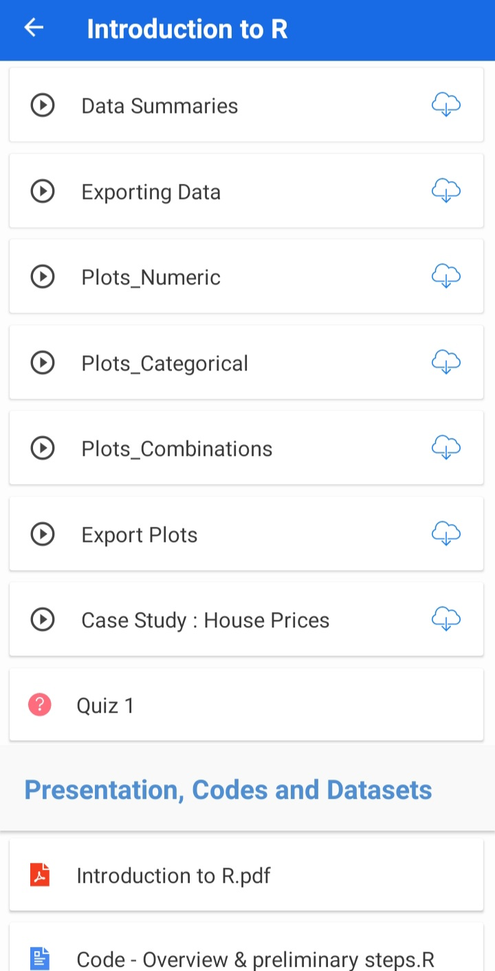



**Coding Challenges:**

Today I solved coding challenge,

**Find the smallest positive integer value that cannot be represented as sum of any subset of a given array sorted in ascending order.**

Given a sorted array (sorted in non-decreasing order) of positive numbers, find the smallest positive integer value that cannot be represented as sum of elements of any subset of given set  
Examples:

Input: arr[] = {1, 3, 6, 10, 11, 15};  
Output: 2  
There are no one or more elements to be added up to get sum = 2

Input: arr[] = {1, 1, 1, 1};  
Output: 5  
1 = 1, 1+1 = 2, 1+ 1 + 1 = 3, 1 + 1 + 1 + 1 = 4,  
There is no elements in the array to get sum 5

Input: arr[] = {1, 1, 3, 4};  
Output: 10  
1 = 1, 1 + 1 = 2, 3 = 3, 1 + 3 = 4, 1 + 4 = 5, 1 + 1 +4 = 6, 3 + 4 = 7........  
To get sum 10, there is no elements in the array.

Input: arr [] = {1, 2, 5, 10, 20, 40}  
Output: 4  
There are no elements to get sum = 4.

Input: arr[] = {1, 2, 3, 4, 5, 6}  
Output: 22

